MIT-WPU
Department of Computer Science and Applications
Practical Assignment No: 06
FYMCA- Div-A, B, and C
Std: MCA- I Subject: Java Programming
Assignment Date 8th September 2025 Submission Date: 8th September 2025

Topic: Array Object, Inheritance, Super, this keyword and Abstract Class
Program -01
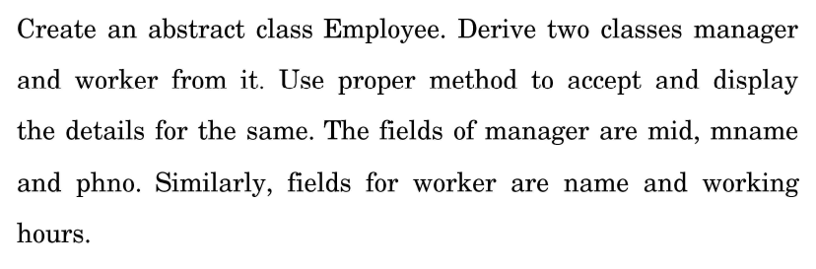
Program -02
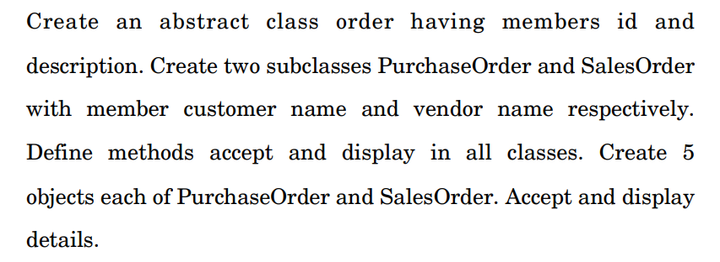
Program -04
Write an application to define an interface ‘CalculateResult’ with methods CalculateTotal(), CalculatePercentage() and CalculateGrade(). Write student class with implementation of ‘CalculateResult’. Create student object and display total marks, percentage and grade of student.

Program -03

Write a Java program to read the lines from console until the given line is “good bye”. Display those lines which contain the word “India” or “Hello”. Also count the number of lines in which pattern is found.

Program -04
Write an application to define an interface ‘CalculateResult’ with methods CalculateTotal(), CalculatePercentage() and CalculateGrade(). Write student class with implementation of ‘CalculateResult’. Create student object and display total marks, percentage and grade of student.

Program -05
Define Class Employee. Define another two subclasses:
(a) Temporary Employee Class (b) Permanent Employee Class
- Calculate salary for temporary employee depending upon no. of hours per month and overtime hours.
- Calculate salary for permanent employee depending upon no. of days per month.
- Override calcsal() method
- Write appropriate constructors
Program -06
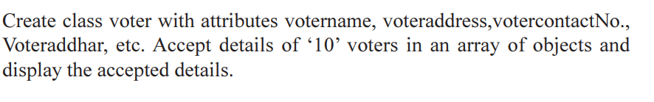Program -07
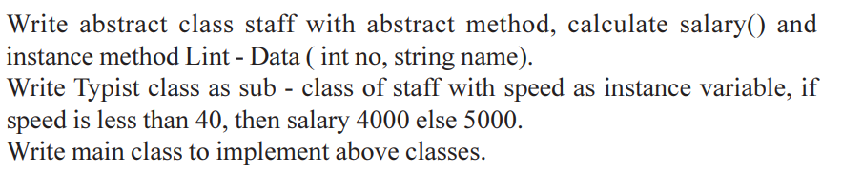Program -08
